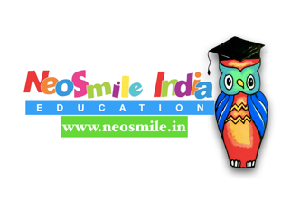
INTERDISCIPLINARY ORTHODODONTICS
#orthodonticsforeveryone

The two days Interdisciplinary Orthodontics course objectives:
Day 1
1.The Orthodontic consultation in Digital era.
Learn the nuances of effective Orthodontic consultation using conventional tools , INTRAORAL SCANNER & EFFECTIVE CASE DISCUSSION.

2. Photo Documentation-an essential component of great
Orthodontic/ DENTAL practice.
A QUICK primer on clinical photo documentation , CHAIRSIDE & STUDIO PHOTOGRAPHY & fast conversion to presentation for case discussion with patients.

3. Imparting clinical decision making in Growing patients for Interceptive Orthodontics.
Lean the tools, that can minimize the impact of developing malocclusion and help in building clinical practice for Comprehensive Orthodontics. Focus on Lingual Arch, palatal appliances, Twin blocks myo-functional appliance, Fixed expanders. When to choose what!

4. Understanding management of impacted teeth with Eruption mechanics.

Hands-on exercises on printed models-
- Lingual Arch fabrication
- Palatal Appliance fabrication
- Band selection & Basic bonding for interdisciplinary appliances

Day 2
5. Imparting clinical information for treating Adult patients who need comprehensive dentistry, wherein Orthodontics can help in achieving the desired outcome.How to manage adjunctive adult patients , especially FMR cases.

6. Mechanics of Deep bite management-the real deal breaker .

7. Intense focus on Ortho-Restorative-Implant prosthodontics interplay with case discussions.

8. Learning basic mechanics for Up righting the tilted teeth, intrusion of supra erupted teeth , extrusion for Adjunctive Ortho-Restorative cases.

9. Utility of orthodontic Micro-implants in adjunctive cases.

10. Panacea of aligners-when to choose them!

Hands-on exercises on printed models-
- Uprighting appliances-making springs
2. Basic Bonding technique for interdisciplinary cases.
3. Micro-implant placement on 3d models.

Disclaimer:
Course is not a Certification/ Diploma/ mastership in Orthodontics.

